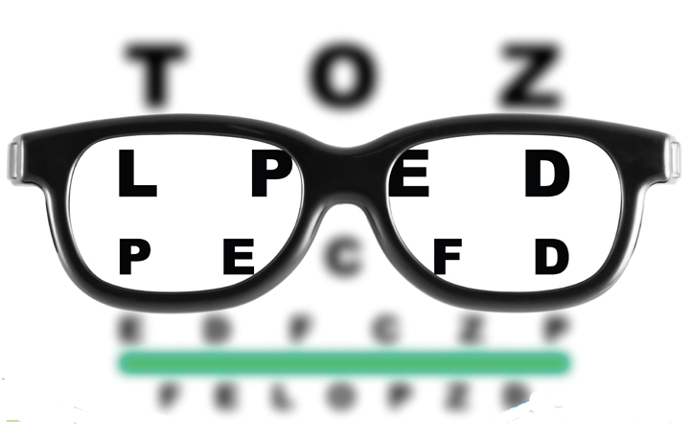
Eye Care Professional Associates

Quarterly

Newsletter
Issue #3 – Summer 2016

In this issue:
- Contact Lenses and Tobacco Use – Safety First, Page 1
- Updates to the Website – Online Scheduling and more, Page 3
- Contact Lens Hygiene – Ew, you’re doing what with your contacts?, Page 4
- Ocular Complications with Diabetes – Early Detection, Page 5

What Contact Lens Wearers Need to Know About Tobacco Use
Dr. Mautino urges consumers to practice safe and healthy habits when handling contact lenses, including not smoking

With a prescription from an eye doctor, consumers choose to wear contact lenses for various reasons—convenience, appearance or to enhance athletic potential—but good hygiene and safety practices must be followed. Dr. Mautino urges consumers not to use tobacco, as smoking can cause harm to eye health.

“Smoke is a major eye irritant, particularly for those who wear contact lenses,” Dr. Mautino. “If you smoke and wear contact lenses, the tar and nicotine that deposits on your fingers can contaminate your contacts when you handle your lenses, which can give your eyes a burning sensation.”

In addition to causing problems associated with poor contact lens hygiene, plus the diseases already associated with tobacco use (lung cancer, emphysema, heart disease, high blood pressure and stroke), individuals who use tobacco are more likely to develop a blinding eye disease called macular degeneration.

“Macular degeneration is a serious disease that can cause diminished color vision and the gradual loss of appear in the center of a person’s vision,” said Dr. Mautino

The bottom line? Avoid tobacco use to maintain good overall health and to ensure your contact lenses will serve you in the best possible way. Use these recommendations from the American Optometric Association (AOA) to ensure you’re following proper hygiene practices when wearing contacts. If not used as directed by an eye doctor, the consequences of improper contact lens use can include infection and even damage to the eye and eye health.
- Always wash and dry your hands before handling contact lenses. According to the AOA’s 2014 American Eye-Q ® survey, 35 percent of contact lens wearers skipped this important step.
- Carefully and regularly clean contact lenses, as directed by your eye doctor. Rub the contact lenses with fingers and rinse thoroughly before soaking lenses overnight in sufficient multi-purpose solution to completely cover the lens.
- Store lenses in the proper lens storage case and replace your case every three months or sooner. Clean the case after each use, and keep it open and dry between cleanings.
- Only fresh solution should be used to clean and store contact lenses. Never re-use old solution. Saline solution and rewetting drops are not designed to disinfect lenses.
- Always follow the recommended contact lens replacement schedule prescribed by your eye doctor. According to the American Eye-Q ® survey, 57 percent of contact lens wearers admitted to wearing disposable contact lenses longer than directed.
- Don’t wear contact lenses while swimming or in a hot tub. According to the FDA and the AOA, contact lenses should not be exposed to any kind of water, including tap water and water in swimming pools, oceans, lakes, hot tubs and showers.
For additional resources about contact lens hygiene and safety, visit contactlenssafety.org or aoa.org. To ensure your eyes are healthy, make an appointment with Dr. Mautino and Eye Care Professional Associates for a comprehensive eye exam at (814)726-1104, or by visiting eyecarewarren.com.

The Times, They Are A-Changin’
More updates to eyecarewarren.com have been flooding in, including online appointment scheduling!

We hope you have been able to use some of the great features on our website! The newest addition to the page is online appointment scheduling. This allows you to look through our available schedule, pick a time, and send the request to us. We will then confirm the appointment with you. Just select your reason for a visit – this can be as simple as a yearly exam, a contact lens fitting, or maybe you are having some problems with a red eye and want to get it checked out.

Below is a picture of the appointment request page to get you acquainted with things. Of course, we still schedule appointments by phone, so feel free to give us a call instead!

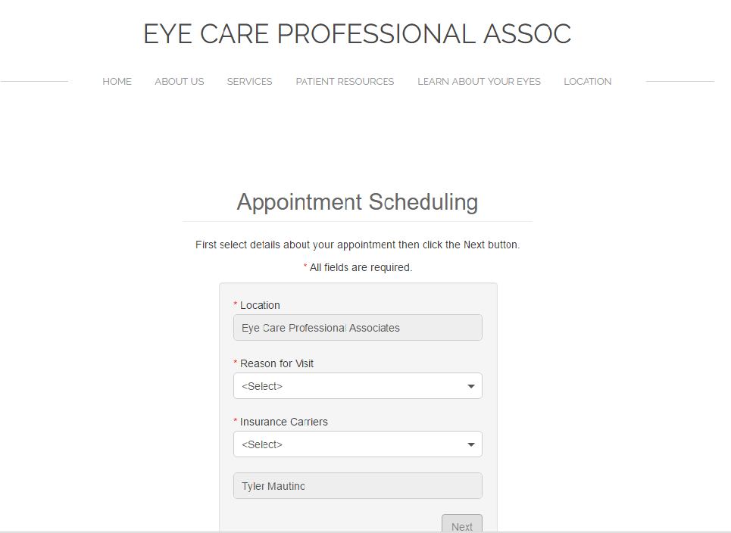

Contact Lens Hygiene
Some people’s contact lens habits are super gross – don’t let that be you!
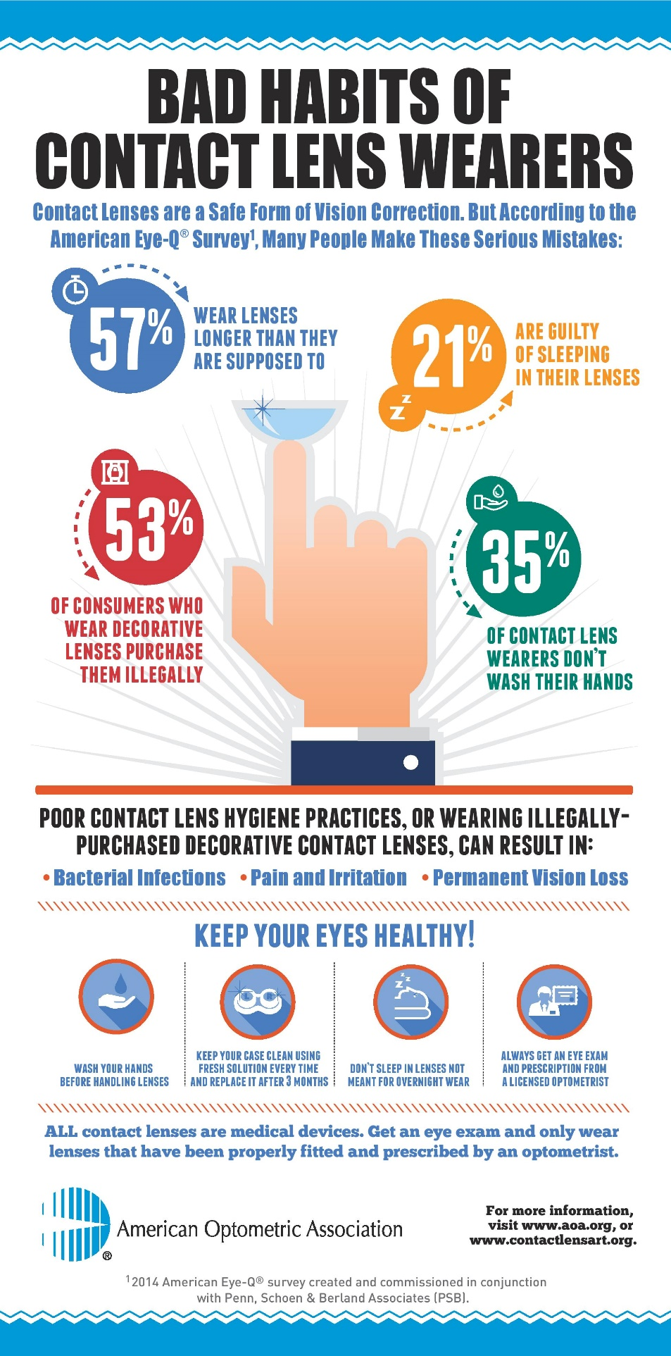

Technology Advancements Enhance Early Detection of Eye Diseases Associated with Diabetes

Eye Care Professional Associates sends reminder that yearly, comprehensive eye exams remain a critical pathway to eye and vision health.

Early symptoms of diabetic eye and vision disorders are often subtle or unnoticed, but new technology, coupled with yearly, comprehensive eye exams, are improving patient outcomes and leading to earlier detection of eye diseases, including those associated with diabetes, which now affects 29 million Americans. If left untreated, these diseases can potentially lead to vision loss or even blindness.

Recently, optometric researchers have deployed a new tool that utilizes advanced optics to detect early warning signs of vision loss that can occur due to diabetes. The instrument uses small mirrors with tiny moveable segments to reflect light into the eye and was successful in finding widespread damage across the retina of patients who were previously not thought to have advanced disease.

“Diabetes is the leading cause of preventable blindness in adults, and eye doctors are continuously working to find new ways to diagnose eye and vision disorders related to this disease,” said Dr. Mautino. “These advancements are critical in offering earlier, better care for patients with diabetes, diabetic retinopathy and other retinal vascular diseases, before an eye problem reaches an advanced stage.”

Individuals with diabetes are at a significantly higher risk for developing eye and vision disorders, including:

Diabetic retinopathy: One of the most serious sight-threatening complications of diabetes, diabetic retinopathy causes progressive damage to the tiny blood vessels that nourish the retina, the light-sensitive lining at the back of the eye. If left untreated, diabetic retinopathy may lead to blindness.

Glaucoma: Those with diabetes are 40 percent more likely to suffer from glaucoma than people without diabetes. Glaucoma is a group of eye diseases characterized by damage to the optic nerve resulting in gradual peripheral vision loss.

Cataracts: With cataracts, the eye’s clear lens clouds, which can block light and interfere with normal vision, and individuals with diabetes are 60 percent more likely to develop cataracts.

Other new advancements are currently in development to further enhance diabetic care, including research on smart contact lenses, which could be used to help monitor blood sugar levels in patients with diabetes and possibly provide a new way to dispense medication slowly over time.

“Though these advancements in technology can assist in the detection and management of eye diseases, they are not replacements for yearly, comprehensive eye exams,” said Dr. Mautino. “When the eyes are dilated, an eye doctor is able to examine the optic nerve, the retina and the retinal blood vessels to assess eye health and even a person’s overall health.”

If you are experiencing any of the following symptoms, contact [your practice here] as soon as possible for a comprehensive eye exam, especially if you have diabetes:

Sudden blurred or double vision

Trouble reading or focusing on near-work

Eye pain or pressure

A noticeable aura or dark ring around lights or illuminated objects

Visible dark spots in vision or images of flashing lights

Eye Care Professional Associates also recommends individuals with diabetes take prescribed medication as directed, keep glycohemoglobin test results (A1C; or average blood sugar level) consistently under seven percent, stick to a healthy diet that includes Omega 3s, fresh fruits and vegetables, exercise regularly, control high blood pressure and avoid alcohol and smoking.

Thanks for Reading!
Dr. Tyler Mautino
Eye Care Professional Associates
60 Hatch Run Rd, Suite 3B
Warren, PA 16365
Office Phone: 814-726-1104, Fax: 814-726-1105
eyecareprofassoc@gmail.com
Hours: 9:00am-7:00pm M
9:00am-6:00pm T-F
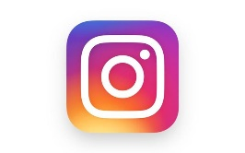
Weekend appointments available!
eyecarewarren.com

