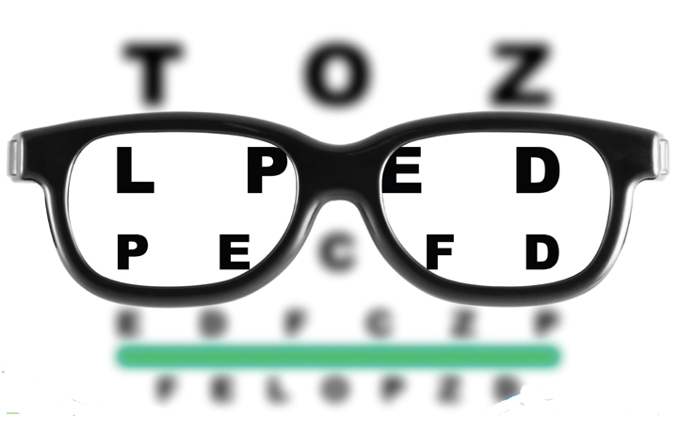
Eye Care Professional Associates

Quarterly

Newsletter
Issue #4 – Fall 2016

In this issue:
- Back to school – Get your child off to a great start, Page 1
- Science Fair - New Eye Movement Discovered, Page 3
- Question and Answer – What is an optometrist?, Page 5

Back-to-School Eye Exams Essential to Helping Children Succeed in the Classroom
Dr. Mautino encourages Making Vision Exams an Annual Back-to-School Tradition

As the new school year approaches, parents are ensuring their children are prepared with an annual physical, immunizations and back-to-school shopping, but an annual eye exam should also be part of a student’s back-to-school routine. According to the American Optometric Association’s (AOA) 2015 American Eye-Q® survey, 89 percent of those surveyed incorrectly believe simple vision screenings, such as those occasionally offered at schools, are an effective way to detect vision problems. However, these screenings cannot detect potentially serious eye and overall health issues in children.
From ages 6 to 18, a child’s vision can change frequently or unexpectedly which can lead to behavioral and attention issues in the classroom. This year, Dr. Mautino encourages parents to start the school year on a healthy note by making comprehensive eye exams a priority and maintaining proper eye health throughout the year.
Dr. Mautino reminds parents to keep these four eye health and safety tips in mind:
- Know that pediatric eye exams are most likely covered by your health insurance plan: Most health insurance plans, including those sold in health insurance marketplaces, cover comprehensive pediatric eye exams. In fact, 54 percent of people were unaware that the Affordable Care Act now defines a comprehensive eye exam as an essential benefit and cover this expense, including glasses for children, annually, according to the AOA’s 2015 American Eye-Q® survey.

- Look for indicators of eye health issues: Common signals that your child may be experiencing a vision problem include covering one eye, holding reading materials close to the face, a short attention span and complaining of headaches or other discomfort.

- Prevent eye strain by monitoring use of digital devices: Increased exposure to electronic devices in and out of the classroom can cause digital eye strain, including burning or itchy eyes, headaches, blurred vision and exhaustion. The AOA recommends following the 20-20-20 rule (taking a 20-second break, every 20 minutes and looking at something 20 feet away), blinking frequently and adjusting your child’s computer screen to prevent glare can prevent discomfort.

- Wear proper eye protection for sports and outdoor activities: Well-fitting, protective eye wear and quality sunglasses that offer UV protection are also critical to maintaining key visual skills for sports and preventing injuries.

“One in four children has an undiagnosed vision problem because changes in their eyesight go unrecognized by both the child and their parents or guardian, said Tyler Mautino, OD. “Making a comprehensive eye exam a priority this year is one of the single most important investments you can make in your child’s education and overall health. While schools typically offer basic vision screenings, these often create a false sense of security by missing significant problems. A comprehensive eye exam is the only way to properly diagnose and treat serious eye health issues.”
To learn more, please visit our website, eyecarewarren.com
###

About the American Eye-Q® survey:
The tenth annual AOA American Eye-Q® survey was created and commissioned in conjunction with Penn, Schoen & Berland Associates (PSB). From February 19—March 4, 2015, PSB conducted 1,000 online interviews among Americans 18 years and older who embodied a nationally representative sample of the U.S. general population. (Margin of error is plus or minus 3.10 percentage points at a 95% confidence level.)
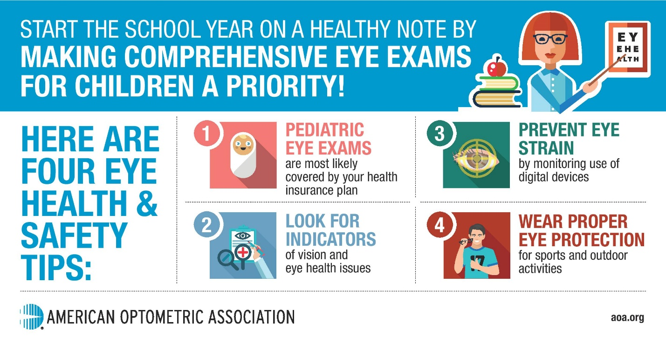

Blink, and you'll miss it: New eye movement discovered
It seems there is more to blinking than meets the eye, as novel research describes a previously unknown, automatic eye movement serving as a visual reset function.
A primary human goal of improving visual inspection of our environment is better understood by this important research finding.
Published Aug. 23 in the biomedical journal eLife, the University of Tubingen (Germany) paper details a specific eye movement synchronized with blinking that helps the eye reset after twisting to view a rotating object. This function, coined a "blink-associated resetting movement" (BARM), helps reduce eye strain as viewers assess their often dynamic environments.

The study sought to determine whether torsional optokinetic nystagmus (tOKN) were synchronized with blinking to minimize interruption of visual perception. To achieve this, subjects' eyes were tracked when viewing a rotating pattern. While tracking, the eyes frequently reset via tOKN to prevent over-rotating beyond the eyes' mechanical limits. Researchers noted this resetting was imperfect, causing the eyes to gradually twist until the muscles couldn't twist any further. Once maximizing their movement, the eyes naturally reset via this BARM.
"To discover such a ubiquitous phenomenon in such a well-studied part of the human body was astonishing to us, and we're very grateful to the volunteers who took part in the study," said lead author Mohammad Farhan Khazali, in a press release.
Shaping our understanding of blinking
Aside from providing much-needed moisture to the ocular surface, blinking also helps protect the eye from irritants and disengages our attention, ever so briefly, to allow the brain to process. Darrell Schlange, O.D., associate professor at Illinois College of Optometry, says clinical evidence also suggests that blinks appear to provide increased intensity of the stimulus for saccades, pursuits, accommodation, vergence and visual attention. "This research investigates the resetting of the tOKN and motor synergy with blinks, thereby reducing the interference in optic flow, enhancing the continuity of visual input and avoiding a decrease in visual processing," Dr. Schlange notes upon reviewing the paper.
Discovery of a consistent, resetting tOKN during a blink supports a conclusion of motor synergy; however, Dr. Schlange says there are alternative theories of this process, such as merely concurrent actions—not synergistic—presented and countered in the paper's experimental findings.
"A primary human goal of improving visual inspection of our environment, without interruption of visual input during blinks, saccades and tOKN, is better understood by this important research finding," Dr. Schlange says, adding the clinical significance of this study is likely limited.
Screen time and eyes
Although such research likely won't influence chairside conversations, it does provide a more complete picture of blinking, especially as the relationship between digital device use and eyesight is scrutinized. A 2014 study determined that subjects reading from a computer screen versus hard copy were no more likely to blink fewer times for one or the other; however, computer-reading subjects were more likely to blink incompletely. It's an association that might help explain anecdotal evidence of increased eye strain and fatigue, and dry eye from prolonged digital device use.
Just as blinking provides a mental break, Dr. Mautino recommends device users follow the 20-20-20 rule (take a 20-second break every 20 minutes to look at something 20 feet away) to provide a visual break from devices and lessen the effects of digital eyestrain.

Question and Answer

America’s Family Eye Doctors: What an Optometrist Can Do for You

Each year, you probably make a mental checklist of health care appointments you need to make. Is the eye doctor on your list? Vision plays an important role in daily life and your optometrist is there to help keep your vision clear and protect your eyes from dangerous diseases that could rob you of your eyesight or worse. As the largest group of eye care providers in the nation, optometrists are the best equipped to care for your family’s eye health needs.

Q: So what is a doctor of optometry?

A: Doctors of Optometry (ODs/optometrists) are the independent primary health care

professionals for the eye. Optometrists examine, diagnose, treat, and manage diseases,

injuries, and disorders of the visual system, the eye, and associated structures as well as identify related systemic conditions affecting the eye. Doctors of optometry are state-licensed to diagnose and treat diseases and disorders of the eye and visual system. An optometrist has completed pre-professional undergraduate education in a college or university and four years of professional education at a college of optometry, leading to the doctor of optometry (O.D.) degree.

Q: What kind of care can an optometrist provide?

A: Your doctor can prescribe medications, low vision rehabilitation, vision therapy, spectacle lenses, contact lenses, and perform certain surgical procedures. Optometrists counsel their patients regarding surgical and non-surgical options that meet their visual needs related to their occupations, avocations, and lifestyle, as well as provide pre- and post- operative care. Optometrists are often the first health care providers to diagnose serious conditions.

Q: How do optometrists serve in their communities?

A: Optometry is known as a caring and compassionate profession and doctors often volunteer and provide eye care to communities in need. Approximately 39,000 optometric health care professionals are members of the American Optometric Association (AOA) and many volunteer through its programs:

Through the program Healthy Eyes Healthy People®, the AOA works with the U.S.Department of Health and Human Services to achieve its goal of promoting eye care as an essential element of the health of Americans.

VISION USA, an AOA charitable program, has provided basic eye and vision care services free of charge to hundreds of thousands of uninsured, low-income, working people who have no other means of obtaining care.

The AOA developed the InfantSEE® program with The Vision Care Institute of Johnson & Johnson Vision Care, Inc., to provide infants up to 1-year- old with a no cost, comprehensive eye assessment by a volunteering optometrist.

Optometrists also serve communities across America by providing services such as eye education programs, free exams and eyeglass fittings in conjunction with charitable organizations, as well as special eye assessments for diabetes patients.

Thanks for Reading!
Dr. Tyler Mautino
Eye Care Professional Associates
60 Hatch Run Rd, Suite 3B
Warren, PA 16365
Office Phone: 814-726-1104, Fax: 814-726-1105
eyecareprofassoc@gmail.com
Hours: 9:00am-7:00pm M
9:00am-6:00pm T-F
Weekend appointments available!
eyecarewarren.com

