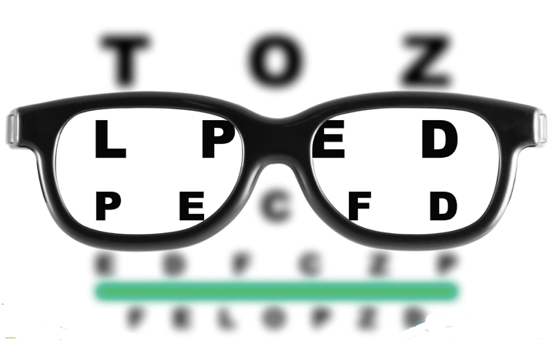
Eye Care Professional Associates

Quarterly

Newsletter
Issue #1 - Winter 2015/2016

In this issue:
- Meet Our Doctor – Learn more about Dr. Mautino, Page 1
- Electronic Health Records – How EHR will benefit you, Page 1
- Dry Eye Syndrome – Spotlight on this common ocular health issue, Page 2
- Stay Up To Date – Follow our social media accounts, Page 4

Meet Our Doctor!
Eye Care Professional Associates is excited to welcome Dr. Tyler Mautino to our practice. Dr. Mautino grew up in Finleyville, PA, just south of Pittsburgh. He attended the University of Pittsburgh where he earned a Bachelor of Arts in Sociology. He received his Doctor of Optometry degree from Nova Southeastern University College of Optometry in Ft. Lauderdale, where he was recognized for his exceptional clinical care with the Jack Wolfe scholarship. Dr. Mautino specializes in primary care optometry, contact lens fittings, dry eye management, diabetic eye exams, and pediatrics. He is a member of the American Optometric Association, the Pennsylvania Optometric Association, and Leadership Warren County. Dr. Mautino and his wife Lindsey moved to Warren in 2015 and spend their time in Warren on their kayak, using their meat smoker, and spending time on Chautauqua Lake with family. Dr. Mautino will be seeing all patients at Eye Care Professional Associates.

New in the Office - Electronic Health Records
Eye Care Professional Associates has recently adopted Eyefinity EHR software to provide its services for the office and our patients. This software will provide huge benefits to our patients that we are very excited to share!

- EHRs reduce your paperwork. The clipboard and new patient questionnaire may remain a feature of your doctor’s office for some time to come. But as more information gets added to your EHR, your doctor and hospital will have more of that data available as soon as you arrive. This means fewer and shorter forms for you to complete, reducing the health care “hassle factor.”
- EHRs get your information accurately into the hands of people who need it. Even if you have relatively simple health care needs, coordinating information among care providers can be a daunting task, and one that can lead to medical mistakes if done incorrectly. When all of your providers can share your health information via EHRs, each of them has access to more accurate and up-to-date information about your care. That enables your providers to make the best possible decisions, particularly in a crisis.
- EHRs help your doctors coordinate your care and protect your safety. Suppose you see three specialists in addition to your primary care physician. Each of them may prescribe different drugs, and sometimes, these drugs may interact in harmful ways. EHRs can warn your care providers if they try to prescribe a drug that could cause that kind of interaction. An EHR may also alert one of your doctors if another doctor has already prescribed a drug that did not work out for you, saving you from the risks and costs of taking ineffective medication.
- EHRs reduce unnecessary tests and procedures. Have you ever had to repeat medical tests ordered by one doctor because the results weren’t readily available to another doctor? Those tests may have been uncomfortable and inconvenient or have posed some risk, and they also cost money. Repeating tests—whether a free eye-pressure test or a $2,000 MRI--results in higher costs to you in the form of bigger bills and increased insurance premiums. With EHRs, all of your care providers can have access to all your test results and records at once, reducing the potential for unnecessary repeat tests.
- EHRs give you direct access to your health records. In the United States, you already have a Federally guaranteed right to see your health records, identify wrong and missing information, and make additions or corrections as needed. Some health care providers with EHR systems give their patients direct access to their health information online in ways that help preserve privacy and security. This access enables you to keep better track of your care, and in some cases, answer your questions immediately rather than waiting hours or days for a returned phone call. This access may also allow you to communicate directly and securely with your healthcare provider.

Eye Health Spotlight - Dry Eye Syndrome

Dry eye is a condition in which there are insufficient tears to lubricate and nourish the eye. Tears are necessary for maintaining the health of the front surface of the eye and for providing clear vision. People with dry eyes either do not produce enough tears or have a poor quality of tears. Dry eye is a common and often chronic problem, particularly in older adults.
With each blink of the eyelids, tears are spread across the front surface of the eye, known as the cornea. Tears provide lubrication, reduce the risk of eye infection, wash away foreign matter in the eye, and keep the surface of the eyes smooth and clear. Excess tears in the eyes flow into small drainage ducts, in the inner corners of the eyelids, which drain in the back of the nose.
The majority of people over the age of 65 experience some symptoms of dry eyes.
The development of dry eyes can have many causes. They include:
- Age – dry eye is a part of the natural aging process. The majority of people over age 65 experience some symptoms of dry eyes.
- Gender – women are more likely to develop dry eyes due to hormonal changes caused by pregnancy, the use of oral contraceptives, and menopause.
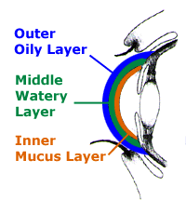
- Medications – certain medicines, including antihistamines, decongestants, blood pressure medications and antidepressants, can reduce the amount of tears produced in the eyes.
- Medical conditions – persons with rheumatoid arthritis, diabetes and thyroid problems are more likely to have symptoms of dry eyes. Also, problems with inflammation of the eyelids, inflammation of the surfaces of the eye, or the inward or outward turning of eyelids can cause dry eyes to develop.
- Environmental conditions – exposure to smoke, wind and dry climates can increase tear evaporation resulting in dry eye symptoms. Failure to blink regularly, such as when staring at a computer screen for long periods of time, can also contribute to drying of the eyes.
- Other factors – long term use of contact lenses can be a factor in the development of dry eyes. Refractive eye surgeries, such as LASIK, can cause decreased tear production and dry eyes.
People with dry eyes may experience symptoms of irritated, gritty, scratchy, or burning eyes, a feeling of something in their eyes, excess watering, and blurred vision. Advanced dry eyes may damage the front surface of the eye and impair vision. Treatments for dry eyes aim to restore or maintain the normal amount of tears in the eye to minimize dryness and related discomfort and to maintain eye health.
Talk to Dr. Mautino about your options for treatment at your next exam. Remember, eye health related issues such as dry eyes are covered under your medical insurance, so you don’t need to wait until your annual exam to have them taken care of.

Thanks for Reading!
Dr. Tyler Mautino
Eye Care Professional Associates
60 Hatch Run Rd
Warren, PA 16365
814-726-1104
eyecareprofassoc@gmail.com
Hours: 9:00am-8:00pm M
9:00am-6:00pm T-F
Weekend appointments available!
Find us on your favorite social media accounts!

